Curriculum Vitae

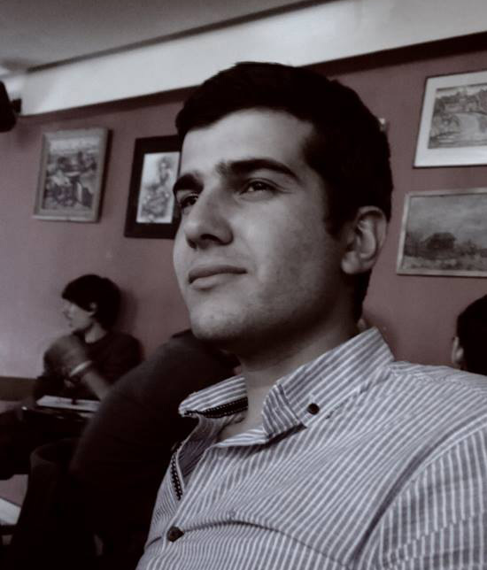
Tigran Shakhbekyan
Personal details:
Birth date: 11.05MAY.1988
Marital status: Married
E-mail: shakhbekyantigran@gmail.com
Linkedin: https://www.linkedin.com/in/tigranshakhbekyan
GitHub: https://github.com/shtigran
Codefights: https://codefights.com/profile/tigran_sh3
OBJECTIVE: DEVELOPER
In my opinion, my chief qualities, are sense of purpose and hardworking, that will help me to become a good programmer. My ability to find solutions to different situations will be useful for my future work.
TECHNICAL SKILLS:

- Languages: C# 6.0, C, C++
- Technics: .NET Framework 4.6, Object Oriented Programming, MS Visual Studio
- Internet Technology: HTML, CSS
- Operating Systems: Unix (Linux), Windows (7, 8)
- Databases: SQL
- VCS: Git Gui, GitHub
- Used books and Websites: A.Troelsen C# 6.0 and .NET 4.6 Framework, https://msdn.microsoft.com, www.pluralsight.com, www.dotnetperls.com
TRAININGS AND SOCIAL ACTIVITIES:
- December 2016 – January 2017: Betconstruct Intership program, Microsoft Innovation Center (C#, .Net Framework)
- January 2017: Certificate of Completion: C# Course, SoloLearn, License 1080-3508443
- October 2016 – present: Programming courses, Topsoft (Programming fundamentals, C#/.NET Framework, HTML, CSS,)
- October – December 2016: Programming course, Dlink Armenia (Linux, C, SQL)
- January 2010: Certificate of training program of Micromine geological program
- Published 1 book, 1 map and 11 Articles in various journals and books (available upon request)
- 2008-2014: Member of the Student Scientific Society of the Yerevan State University
LANGUAGES:
- Armenian -native
- Russian - fluent
- English – fluent (TOEFL)
AWARDS RECEIVED:
- 2012-2014: Certificates of Appreciation for the reports in scientific conferences in Armenia, Georgia, Russia
- 2009: Silver medal and Certificate of Appreciation for the Best student of the Yerevan State University
- 2007-2009: Certificates for the organization of conferences Armenia
EDUCATION:

- Yerevan, Armenia Sep.  2011 – May 2014 : | Yerevan State University, Department of Geology and Geography PhD student, PhD degree
- Yerevan, Armenia Sep.  2009 – May 2011 : | Yerevan State University, Department of Geology and Geography, Master of Science (Diploma with Honor)
- Yerevan, Armenia Sep.  2005 – May 2009 : | Yerevan State University, Department of Geology, Bachelor’s Degree (Diploma with Honor)
- Gyumri, Armenia  1995-2005: | № 10 secondary School

EXPERIENCE:

- June 2013- present  Nagorno-Karabakh, Armenia | "Freedom Mining" LLC, Geological prospecting and exploration, geologist
- June 2010 - November 2012  Regions of Syunik, Gegharqunik Armenia | "Abvan" Ltd, Geological prospecting and exploration, geologist
- September- October-2009  Region of Lori, Armenia | Geophysical survey of the Mghart gold ore field, geophysicist
- September- October-2008  Region of Lori, Armenia | Armenian-Russian archaeological expedition, geologist
- June- August-2008,  Region of Gegharqunik, Armenia | "Abvan" Ltd, Geological prospecting and exploration, engineer geologist
- September- October-2007  Region of Lori, Armenia | Armenian-Russian archaeological expedition, geologist
- August-2007  Region of Gegharqunik, Armenia | Geological prospecting and exploration, field assistant
- July-2007  Regions of Armenia | "Structural geology and geological mapping, geophysics", summer field work
- July – 2006  Regions of Armenia | "General geology of the Republic of Armenia", summer field work

Yerevan 2017

